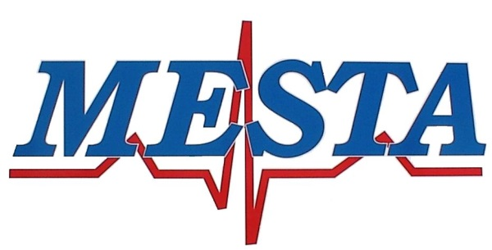

918-825-6825 Phone 918-825-6829 Fax

NOTICE
Pursuant to, and in accordance with Oklahoma Statues Title 25, Section 311, notice is hereby given of the regularly scheduled meeting of the Mayes Emergency Services Trust Authority at 5:00PM January 9^{th,} 2024, at the MESTA Main Station #1, 4144 Redden Street, Pryor, Oklahoma.

AGENDA

- Call to order.
- Consent agenda
- Regular Board Meeting Minutes of December 12th, 2023
- Financial Statement of December 2023
- Claims for payment
- Request for Blanket purchase orders
- Transfer of funds necessary to cover expense
- Attorney report
- Director report

Regular Agenda

- New Business: Consideration and possible Board action with respect to any other matters not known about or which could not have been reasonably foreseen prior to posting the agenda.
- Discussion and possible Board action on purchasing 6 sets of mattresses and box springs from Kla-Mart
- Discussion and possible Board action regarding delegation of authority to a working group of Trustees to address and take appropriate action on issues presented to the Chairperson and other Trustees, specifically complaints and concerns by certain employees regarding supervisory and management personnel.
- Discussion and possible Board action on an executive session of the Board, as authorized by Title 25, Section 207 B.1 of the Oklahoma Statutes, for the purpose of discussing the employment of Bradley A. Reed as the Executive Director of the Authority.
- After a return by the Board of Trustees to the public meeting, discussion and possible action on any item of business considered during the Executive Session which concerns the employment of Bradley A. Reed as the Executive Director of the Authority.
- Citizens input, open to all Citizens limited to 2 minutes per individual.
- Adjournment.

Posted January 5th, 2024

Brandon Hawkins

Director of MESTA

