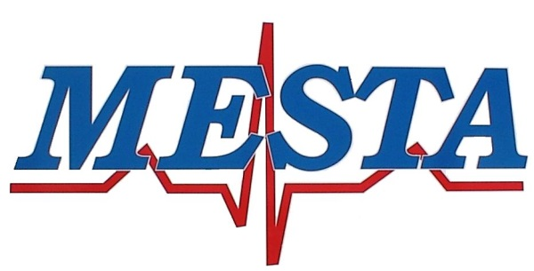

918-825-6825 Phone 918-825-6829 Fax

NOTICE
Pursuant to, and in accordance with Oklahoma Statues Title 25, Section 311, notice is hereby given of the regularly scheduled meeting of the Mayes Emergency Services Trust Authority at 5:00PM November 14th, 2023, at the MESTA Main Station #1, 4144 Redden Street, Pryor, Oklahoma.

AGENDA

- Call to order.
- Consent agenda
- Regular Board Meeting Minutes of October 10th, 2023
- Financial Statement of October 2023
- Claims for payment
- Request for Blanket purchase orders
- Transfer of funds necessary to cover expense
- Attorney report
- Director report

Regular Agenda

- New Business: Consideration and possible Board action with respect to any other matters not known about or which could not have been reasonably foreseen prior to posting the agenda.
- Discussion and possible Board action on a report from the Executive Director Search Committee
- Discussion and possible Board action on approving the scheduled meeting dates of the Authority for the year 2024
- Discussion and election of Officers for the MESTA Board including but not limited to 1-Chair, 2-Vice Chair, 3-Treasurer
- Discussion and possible Board action on displaying the memorial for John Emmen, commissioning the MESTA Wall of Honor
- Discussion and possible Board action on approving payment to TC Advisors for preparation and submission of the amended form 941 as it relates to the Employee Retention Credit (ERC) specifically Q3 2020 and Q1 2021
- Discussion and possible Board action on approving a one time pay allowance for MESTA employees
- Discussion and possible Board action on approving the purchase of one or two ambulance(s) along with payment/finance options
- Citizens input, open to all Citizens limited to 2 minutes per individual.
- Adjournment.

Posted November 10th, 2023

Brandon Hawkins

Director of MESTA

